Name(s)__Ryder Dale Walton && Chance Turner__

DB Homework 11

You may complete this with one partner.

Due Tues, Nov 29th

(20 pts)

Turn In: This document, with SQL statements copied below each question.

1. Refer to figure P8.19 on p. 421. Modify the Ch08_LargeCo_SQL script with constraints (where appropriate) to implement the following:

* Primary Keys
* Foreign Key (to avoid tedious hassles, do not create the FK constraints between employee and department)
* For the Invoice-Line FK relationship, create a Cascade Delete/Update

Syntax Examples for constraints: <https://msdn.microsoft.com/en-us/library/ms189049.aspx>

Create a new empty database in Sql Server and test your script. You will need to make some minor changes to get the PK and FK constraints to work:

* Make sure the primary key fields are specified as NOT NULL;
* Make sure the FK field and the PK it references have identical definitions (e.g., one can’t say NUMBER and the other say NUMBER(6,0)…the types must be identical.

CREATE TABLE lgbrand (

brand_id numeric(4,0) NOT NULL,

brand_name VARCHAR(100) NULL,

brand_type VARCHAR(20) NULL,

CONSTRAINT PK_LGBRAND PRIMARY KEY (BRAND_ID)

);

CREATE TABLE lgproduct (

prod_sku VARCHAR(15) NOT NULL,

prod_descript VARCHAR(255) NULL,

prod_type VARCHAR(255) NULL,

prod_base VARCHAR(255) NULL,

prod_category VARCHAR(255) NULL,

prod_price NUMERIC(10,2) NULL,

prod_qoh NUMERIC(10,0) NULL,

prod_min NUMERIC(10,0) NULL,

brand_id NUMERIC(4,0) NULL,

CONSTRAINT PK_LGPRODUCT PRIMARY KEY (PROD_SKU),

CONSTRAINT FK_LGBRAND_LGPRODUCT FOREIGN KEY (BRAND_ID)

REFERENCES LGBRAND (BRAND_ID)

ON DELETE CASCADE

ON UPDATE CASCADE

);

CREATE TABLE lgvendor (

vend_id NUMERIC(6,0) NOT NULL,

vend_name VARCHAR(255) NULL,

vend_street VARCHAR(50) NULL,

vend_city VARCHAR(50) NULL,

vend_state VARCHAR(2) NULL,

vend_zip VARCHAR(5) NULL,

CONSTRAINT PK_LGVENDOR PRIMARY KEY (VEND_ID)

);

CREATE TABLE lgsupplies (

prod_sku VARCHAR(15) NOT NULL,

vend_id NUMERIC(6,0) NOT NULL,

CONSTRAINT PK_LGSUPPLIES PRIMARY KEY (PROD_SKU, VEND_ID),

CONSTRAINT FK_LGSUPPLIES_LGPRODUCT FOREIGN KEY (PROD_SKU)

REFERENCES LGPRODUCT (PROD_SKU)

ON DELETE CASCADE

ON UPDATE CASCADE,

CONSTRAINT FK_LGSUPPLIES_LGVENDOR FOREIGN KEY (VEND_ID)

REFERENCES LGVENDOR (VEND_ID)

ON DELETE CASCADE

ON UPDATE CASCADE

);

CREATE TABLE lgdepartment (

dept_num NUMERIC(5,0) NOT NULL,

dept_name VARCHAR(50) NOT NULL,

dept_mail_box VARCHAR(3) NULL,

dept_phone VARCHAR(9) NULL,

emp_num NUMERIC(6,0) NULL,

CONSTRAINT PK_LGDEPARTMENT PRIMARY KEY (DEPT_NUM),

);

CREATE TABLE lgemployee (

emp_num NUMERIC(6,0) NOT NULL,

emp_fname VARCHAR(20) NULL,

emp_lname VARCHAR(25) NOT NULL,

emp_email VARCHAR(25) NOT NULL,

emp_phone VARCHAR(20) NULL,

emp_hiredate DATE NOT NULL,

emp_title VARCHAR(45) NOT NULL,

emp_comm NUMERIC(2,2) NULL,

dept_num NUMERIC(5,0) NULL,

CONSTRAINT PK_LGEMPLOYEE PRIMARY KEY (EMP_NUM),

CONSTRAINT FK_LGEMPLOYEE_LGDEPARTMENT FOREIGN KEY (DEPT_NUM)

REFERENCES LGDEPARTMENT (DEPT_NUM)

);

CREATE TABLE lgsalary_history (

emp_num NUMERIC(6,0) NOT NULL,

sal_from DATE NOT NULL,

sal_end DATE NULL,

sal_amount NUMERIC(10,2) NULL,

CONSTRAINT PK_LGSALARYHISTORY PRIMARY KEY (EMP_NUM, SAL_FROM),

CONSTRAINT FK_LGSALARYHISTORY_LGEMPLOYEE FOREIGN KEY (EMP_NUM)

REFERENCES LGEMPLOYEE (EMP_NUM)

ON DELETE CASCADE

ON UPDATE CASCADE

);

CREATE TABLE lgcustomer (

cust_code NUMERIC(38,0) NOT NULL,

cust_fname VARCHAR(20) NOT NULL,

cust_lname VARCHAR(20) NOT NULL,

cust_street VARCHAR(70) NULL,

cust_city VARCHAR(50) NULL,

cust_state CHAR(2) NULL,

cust_zip CHAR(5) NULL,

cust_balance NUMERIC(8,2) NULL,

CONSTRAINT PK_LGCUSTOMER PRIMARY KEY (CUST_CODE)

);

CREATE TABLE lginvoice (

inv_num NUMERIC(38,0) NOT NULL,

inv_date DATE NULL,

cust_code NUMERIC(38,0) NULL,

inv_total NUMERIC(11,2) NULL,

employee_id NUMERIC(6,0) NULL,

CONSTRAINT PK_LGINVOICE PRIMARY KEY (INV_NUM),

CONSTRAINT FK_LGINVOICE_LGCUSTOMER FOREIGN KEY (CUST_CODE)

REFERENCES LGCUSTOMER (CUST_CODE),

CONSTRAINT FK_LGINVOICE_LGEMPLOYEE FOREIGN KEY (EMPLOYEE_ID)

REFERENCES LGEMPLOYEE (EMP_NUM)

);

CREATE TABLE lgline (

inv_num NUMERIC (38,0) NOT NULL,

line_num NUMERIC NOT NULL,

prod_sku VARCHAR(15) NULL,

line_qty NUMERIC NULL,

line_price NUMERIC(8,2) NULL,

CONSTRAINT PK_LGLINE PRIMARY KEY (INV_NUM, LINE_NUM),

CONSTRAINT FK_LGLINE_LGINVOICE FOREIGN KEY (INV_NUM)

REFERENCES LGINVOICE (INV_NUM)

ON DELETE CASCADE

ON UPDATE CASCADE,

CONSTRAINT FK_LGLINE_LGPRODUCT FOREIGN KEY (PROD_SKU)

REFERENCES LGPRODUCT (PROD_SKU)

);

--Only including the Create statements. Otherwise, this document would be over 630 pages long. We didn’t do anything with the inserts anyway.

Write sql server statements as needed to answer the following questions. Copy/paste the sql you use for each question below.

1. How many line items are associated with invoice 106?

SELECT COUNT(L.line_num) AS Line_Items

FROM lgline L

where L.inv_num = 106;

1. Delete invoice 106, and verify that the associated line items are removed. Show the sql below.

DELETE FROM lginvoice

WHERE inv_num = 106;

SELECT * FROM lgline; --used this to verify they were gone

1. Show a sql statement below that will cause an error due to one of your foreign key constraints. Copy/paste the sql and the error message below.

DELETE FROM lgdepartment

WHERE dept_num = 200;

Msg 547, Level 16, State 0, Line 1

The DELETE statement conflicted with the REFERENCE constraint "FK_LGEMPLOYEE_LGDEPARTMENT". The conflict occurred in database "Homework_11", table "dbo.lgemployee", column 'dept_num'.

The statement has been terminated.

1. Show a sql statement below that will cause an error due to one of your primary key constraints. Copy/paste the sql and the error message below.

INSERT INTO lgdepartment(dept_num)

VALUES (200); -- got same error whether I inserted null or 200

Msg 515, Level 16, State 2, Line 1

Cannot insert the value NULL into column 'dept_name', table 'Homework_11.dbo.lgdepartment'; column does not allow nulls. INSERT fails.

The statement has been terminated.

1. Write a sql statement that will list all customer codes who have not purchased anything.

SELECT cust_code

FROM lgcustomer

WHERE cust_code NOT IN (SELECT cust_code

FROM lginvoice);

1. Write a sql statement that will list all brands for which we do not have products.

SELECT *

FROM lgbrand

WHERE brand_id NOT IN (SELECT brand_id

FROM lgproduct);

1. Refer to your results from the previous two problems. Write a console application that will use two sql delete statements to delete one of the inactive customers and one of the unused brands (you may hard-code the specific customer and brand to delete). This must use Dapper, and it must be done via two Execute statements. Copy/paste your source code below.

using System;

using Dapper;

using System.Data.SqlClient;

using System.Collections.Generic;

using System.Data;

using System.Linq;

namespace HW_11

{

class Program

{

static void Main(string[] args)

{

//Connection String to the database as a whole.

const string CONNECTION_STRING = @"Data Source = .\SQLEXPRESS;" +

@"Initial Catalog = Homework_11;" +

@"Integrated Security = True;" +

@"Connect Timeout = 15;" +

@"Encrypt = False;" +

@"TrustServerCertificate = True;" +

@"ApplicationIntent = ReadWrite;" +

@"MultiSubnetFailover = False";

//Dapper Database Request to delete unused customer.

using (IDbConnection conn = new SqlConnection(CONNECTION_STRING))

{

conn.Execute("DELETE FROM lgcustomer WHERE cust_code = 393");

}

//Dapper Database Request to delete unused brand.

using (IDbConnection conn = new SqlConnection(CONNECTION_STRING))

{

conn.Execute("DELETE FROM lgbrand WHERE brand_id = 24");

}

}

}

} // Verified that this worked by checking with the queries from 6 and 7

1. Repeat the previous question, but *after* deleting an inactive customer, delete a brand that ***is*** referenced by a product (this should cause a run time error). Both deletes should be performed within the same transaction, as illustrated here: <http://stackoverflow.com/questions/24650710/proper-way-of-using-begintransaction-with-dapper-idbconnection>. You must use a try…catch to handle the error gracefully.
   1. Note: the Execute() statement accepts the transaction as an optional final parameter.
   2. Verify that *neither* table was modified by the deletion (this should be handled by the transaction).
   3. You need to wrap the transaction.Rollback() in *another* try/catch, since the rollback itself will fail if the transaction was already automatically rolled back by the database.
   4. Copy/paste your source code below, and insert a screen-shot of the error message produced by your program.

using System;

using Dapper;

using System.Data.SqlClient;

using System.Collections.Generic;

using System.Data;

using System.Linq;

namespace HW_11

{

class Program

{

static void Main(string[] args)

{

//Connection String to the database as a whole.

const string CONNECTION_STRING = @"Data Source = .\SQLEXPRESS;" +

@"Initial Catalog = Homework_11;" +

@"Integrated Security = True;" +

@"Connect Timeout = 15;" +

@"Encrypt = False;" +

@"TrustServerCertificate = True;" +

@"ApplicationIntent = ReadWrite;" +

@"MultiSubnetFailover = False";

using(IDbConnection conn = new SqlConnection(CONNECTION_STRING))

{

conn.Open();

using (var tran = conn.BeginTransaction())

{

try

{

// DB requests go here

conn.Execute("DELETE FROM lgcustomer WHERE cust_code = 730", transaction: tran);

conn.Execute("DELETE FROM lgbrand WHERE brand_id = 23", transaction: tran);

tran.Commit();

} catch (Exception Ex) //handle any exception

{

Console.WriteLine(Ex.Message);

try

{

tran.Rollback(); // If an exception is raised by the FK_Constraint, then enter this block.

Console.WriteLine("Transaction rolled back.");

}

catch (SqlException SqlEx) // handle only rollback exception

{

Console.WriteLine(SqlEx.Message);

Console.WriteLine("The transaction was already rolled back by the DBMS.");

}

}

}

}

}

}

}

// Checked the Database using the 6 and 7 queries again. Neither were deleted.

// Screenshot

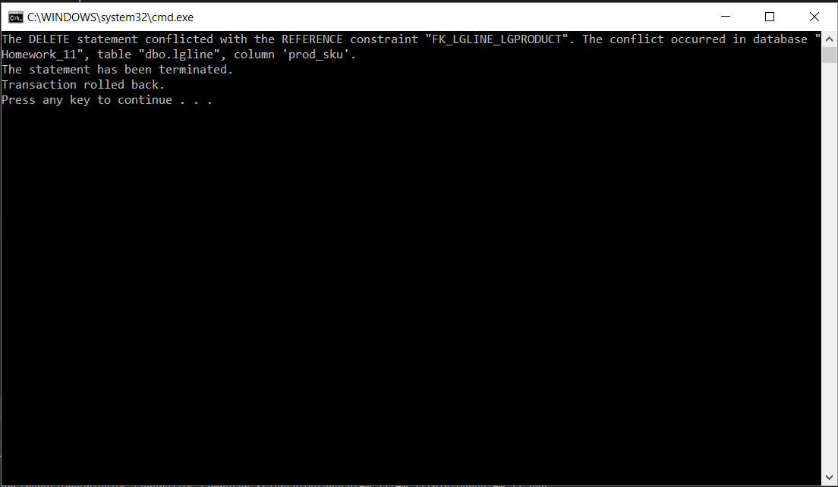

**Turn In:**

This document to bboard, containing sql and C# source code.